# Servers

You have two web servers available to you. Both servers offer PHP and MySQL. The exercises require you to make use of both servers at various times. You need an account on the server to have web space on it AND an account for its associated MySQL database application, see the instructions below.

|  |  |  |  |
| --- | --- | --- | --- |
| daydream This is a windows based server.  You may already have accounts for daydream, either from a previous module or because I submitted your name on a student list before the module started. However, if not you will need to apply for them. To apply for these accounts to be created, visit http://daydream.lsbu.ac.uk and use the links on the left hand side of the page to fill in the application forms. Remember, you need to apply for both a web account and a MySQL account: there are two forms to fill in.    To log in using **FileZilla** use:   |  |  |  | | --- | --- | --- | | **Protocol:** *ftp* | **Host:** *daydream.lsbu.ac.uk* | **Port:** *21* |   **Username:** *your normal username*  **Password:** *your student number*  The web root folder is the only folder you have access to.   * PHPMyAdmin is provided for managing your MySQL database. Log-in with the same details as above at <http://daydream.lsbu.ac.uk/phpmyadmin>. * No terminal access is provided. * The web server and FTP access are both available from off-campus (this is a publicly visible server).   View your web pages at a URL in this form: **daydream.lsbu.ac.uk/myweb/*yourusername*** |

|  |  |  |  |
| --- | --- | --- | --- |
| meno This is a linux-based server.  All students automatically have a linux user account on the ***meno*** server, however you must create an account to use the MySQL database server.  To create an account for MySQL on the ***meno*** server, which you can do by completing the form at <https://my.lsbu.ac.uk/my/portal/Study-Support/IT-Support/Apply-for-MySQL-account> (you need to log in to MyLSBU when accessing this link).  Once the form has been submitted you will receive account details in your LSBU email account.  To log in using **FileZilla** use:   |  |  |  | | --- | --- | --- | | **Protocol:** s*ftp* | **Host:** *meno.lsbu.ac.uk* | **Port:** *22* |   **Username:** *your normal username*  **Password:** *your normal LBSU password*  The web root folder is called **.public_html** (note the leading dot).   * PHPMyAdmin is not available. * To log in at the console use the ***Putty*** application and log in to meno.lsbu.ac.uk with the details above. * To access the MySQL command prompt use your normal username and the MySQL password emailed to you when you applied for an account. * This server can only be accessed within the university LAN (or the VPN you can set up from home). Web pages are not publicly visible and the server does not accept connections from ***FileZilla*** or ***Putty*** from outside the LAN.   View your web pages at a URL in this form: **meno.lsbu.ac.uk/*yourusername*** |

## FileZilla and Putty

### FileZilla

FileZilla is an FTP and SFTP client available on all the university lab machines. It is used to move files between the PC you are working on and a remote server. You will use it to upload HTML, CSS and PHP files to the server.

Instructions on using FileZilla are available here:  
<https://wiki.filezilla-project.org/FileZilla_Client_Tutorial_%28en%29>

### Putty

Putty is a terminal emulator program that provides command line access to remote computers. You will not need it much, but some exercises require you to access your MySQL database at the command line. Instructions for logging in to meno with Putty are given below:

* 1. Login as shown:

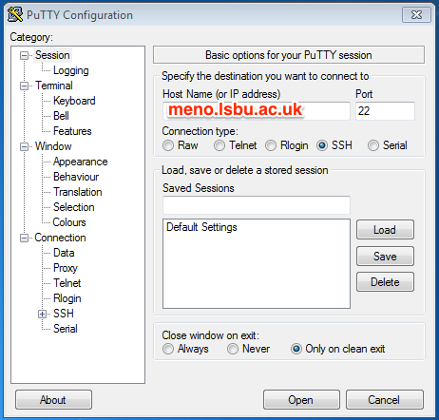

* 1. Click 'Yes' to indicate that you trust the host server.
  2. Login using your LSBU username and password. (Note that you won't see anything happening as you type in your password, before entering it.)
  3. You might find it helpful to “Use system colours” within PuTTY:

